**INDEX**

|  |  |  |
| --- | --- | --- |
| **Sr. No.** | **Practical Name** | **Teacher Sign** |
| 1 | a) Write a [Python Program to Calculate the Area of a Triangle](https://www.programiz.com/python-programming/examples/area-triangle)  b) Write a [Python Program to Swap Two Variables](https://www.programiz.com/python-programming/examples/swap-variables)  c) Write a [Python Program to Convert Celsius to Fahrenheit](https://www.programiz.com/python-programming/examples/celsius-fahrenheit) |  |
| 2 | a.) Write a [Python Program to Check if a Number is Odd or Even](https://www.programiz.com/python-programming/examples/odd-even)  b.) Write a [Python Program to Check if a Number is Positive, Negative or 0](https://www.programiz.com/python-programming/examples/positive-negative-zero)  c.) Write a [Python Program to Check Armstrong Number](https://www.programiz.com/python-programming/examples/armstrong-number) |  |
| 3 | a.) Write a Python program to check if a given number is Fibonacci number?  b.) Write a Python program to print cube sum of first n natural numbers.  c.) Write a Python program to print all odd numbers in a range. |  |
| 4 | a.) Write a Python Program to Print Pascal Triangle  Hint: Enter number of rows: 4  1  1 1  1 2 1  1 3 3 1  b.) WAP to Draw the following Pattern for n number:  1 1 1 1 1  2 2 2 2  3 3 3  4 4  5 |  |
| 5 | Write a program with a function that accepts a string from keyboard and create a new string after converting character of each word capitalized. For instance, if the sentence is “stop and smell the roses” the output should be “Stop And Smell The Roses” |  |
| 6 |  |  |
| 7 |  |  |

**Program 1:**

1. **Write a Python Program to Calculate the Area of a Triangle**

**Software used: PyCharm Community Edition**

**Code:**

height = float(input())  
base = float(input())  
  
area = 0.5 * base * height  
if height > 0 asnd base > 0:  
 print("Area of Triangle: ",area)  
else:  
 print("values of Height and Base must be greater than 0")

# 

# Output :

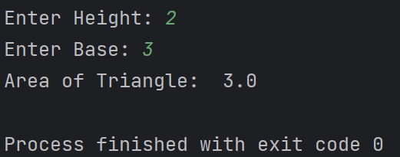

**Program 1:**

1. **Write a Python Program to Swap Two Variables**

**Code:**

n1= input("Enter the first Number

: ")  
n2 = input("Enter the second Number: ")  
  
n1, n2 = n2, n1  
  
print("After swapping:")  
print(f"First Number: {n1}")  
print(f"Second Number: {n2}")

**OUTPUT :**

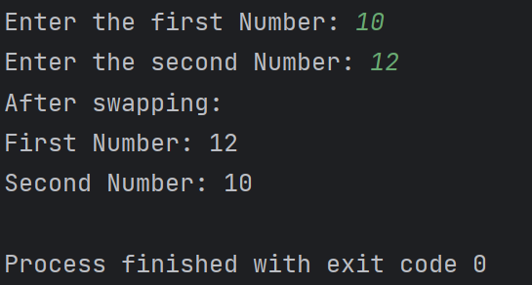

**Program 1:**

# Write a Python Program to Convert Celsius to Fahrenheit

celsius = float(input("Enter temp in Celsius: "))  
fahrenheit = (celsius * 9/5) + 32  
print(f"Temperature in Fahrenheit: {fahrenheit} F")

**OUTPUT :**

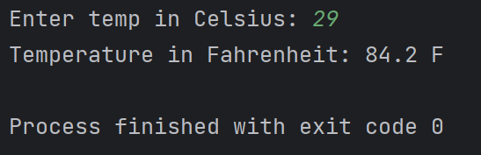

**Program 2 :**

1. **Write a Python Program to Check if a Number is Odd or Even**

**Solution :**

**Code:**

n=int(input("Enter Your Number: "))  
if n%2==0 :  
 print("Number entered is Even ")  
else :  
 print("Number entered is Odd ")

**OUTPUT :**

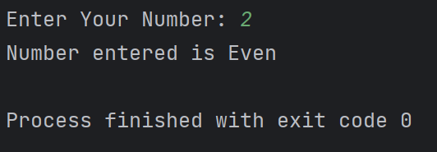

**Program 2 :**

1. **Write a Python Program to Check if a Number is Positive, Negative or 0**

**Code:**

n=int(input("Enter Your Number: "))  
if n>0 :  
 print("Number is positive")  
elif n==0:  
 print("Number is zero ")  
else :  
 print("Number is Negative")

**OUTPUT :**

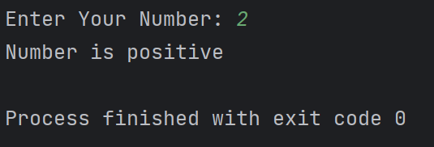

**Program 2 :**

1. **Write a Python Program to Check Armstrong Number**

**Code:**

num = int(input("Enter a number: "))  
num_digits = len(str(num))  
sum = 0  
num_1 = num  
while num_1 > 0:  
 digit = num_1 % 10  
 sum += digit ** num_digits  
 num_1 //= 10  
if num == sum:  
 print(f"{num} is an Armstrong number.")  
else:  
 print(f"{num} is not an Armstrong number.")

**OUTPUT :**

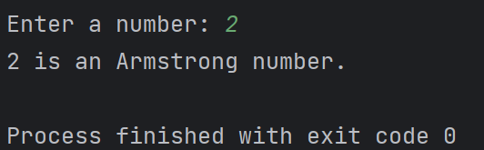

**Program 3:**

# Write a Python program to check if a given number is

# Fibonacci number?

# Code:

n=int(input("Enter the number: "))  
c=0  
a=1  
b=1  
if n==0 or n==1:  
 print(n,"is a Fibonacci Number")  
else:  
 while c<n:  
 c=a+b  
 b=a  
 a=c  
 if c==n:  
 print(n,"is a Fibonacci Number")  
 else:  
 print(n,"is not a Fibonacci Number")

# Output:

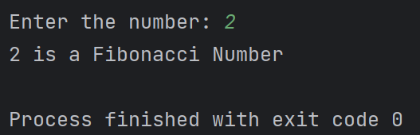

1. **Write a Python Program to print cube sum of first n natural numbers.**

**Code:**

def sumOfCubes(n) :  
 if n < 0:  
 return  
 sum = 0  
 for i in range(n+1):  
 sum += pow(i, 3)  
 return sum  
  
n = int(input('Enter the Number: '))  
sum = sumOfCubes(n)  
print(f'Sum of Cubes: {sum}')

**Output:**

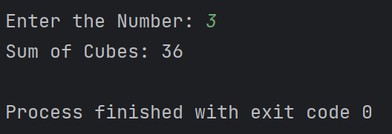

# Write a Python Program to print all odd numbers in a range.

# Code:

start = int(input("Enter the start of range: "))  
end = int(input("Enter the end of range: "))  
  
print("Odd numbers in the Range: ")  
for num in range(start, end + 1):  
 if num % 2 != 0:  
 print(num)

# Output:

# 

**Program 4 :**

**a.) Write a Python Program to Print Pascal Triangle**

**Hint: Enter number of rows: 4**

# 1

# 1 1

# 1 2 1

# 1 3 3 1

**Code:**

n = int(input("Enter the Number of Rows: "))  
  
for i in range(n):  
 # adjust space  
 print(' ' * (n - i), end='')  
 print(' '.join(map(str, str(11 ** i))))

**OUTPUT :**

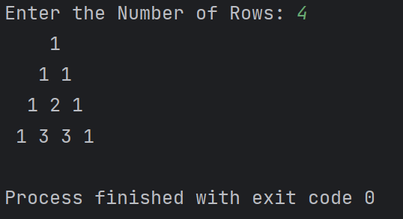

**b.) WAP to Draw the following Pattern for n number:**

**1 1 1 1 1**

**2 2 2 2**

**3 3 3**

**4 4**

**5**

**Code:**

n=int(input("Enter the Number of Rows: "))  
currRow=1  
while currRow<=n:  
 currCol=1  
 while currCol<=(n-currRow+1):  
 print(currRow,end="")  
 currCol+=1  
 print()  
 currRow+=1

**Output :**

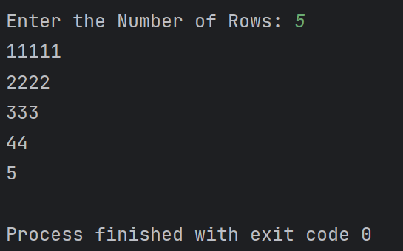

**Program 5 :**

**Write a program with a function that accepts a string from keyboard and create a new string after converting character of each word capitalized. For instance, if the sentence is “stop and smell the roses” the output should be “Stop And Smell The Roses”**

**Code:**

def capitalize_words(input_str):  
 words = input_str.split()  
 capitalized_words = [word.capitalize() for word in words]  
 return " ".join(capitalized_words)  
  
try:  
 input_str = input("Enter a sentence: ")  
 result_str = capitalize_words(input_str)  
 print("Capitalized String: ",result_str)  
except ValueError:  
 print("Invalid input. Please enter a valid sentence.")

# Output:

# 